**The Future of Heating in 2050**

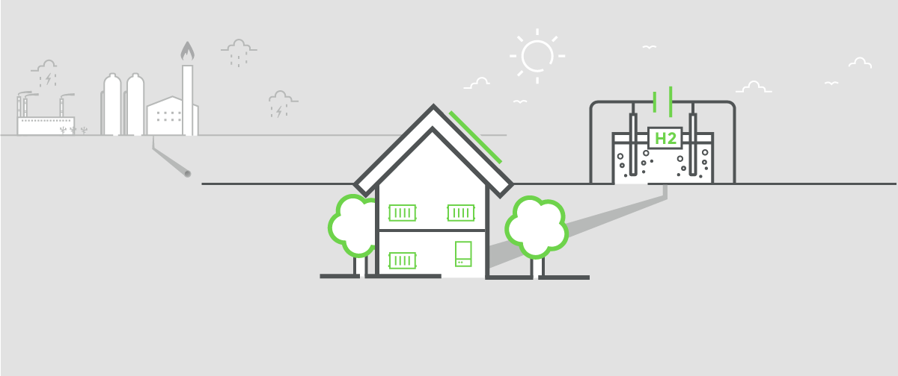

This article was updated in March 2019.

Time is running out to meet our carbon reduction targets and the way we live has to change. A big part of that will be saying goodbye to our gas and oil boilers. But, without fossil fuels, how will we be heating our homes in 2050?

Why Do We Need to Change the Way We Heat Our Homes?

For hundreds of years we’ve been powering our homes, transport and industry with fossil fuels like natural gas, oil and coal. While these fuels have enabled us to take huge steps forward both economically and technologically, we can’t go on using these fuels forever. Not only are our supplies running out, but the long term environmental impact on our climate is now an urgent and international concern.

In 2008 the UK government passed the Climate Change Act in an effort to tackle the issue. The Act makes it the duty of the Secretary of State for Energy and Climate Change to ensure that the UK’s carbon emissions are at least 80% lower than the 1990 baseline by 2050. The Act also gives ministers powers to introduce new measures to achieve these targets.

It’s a tall order, especially when you consider that they are trying to achieve this alongside the following objectives set out by the Department of Business, Energy and Industrial Strategy (BEIS):

* Keep energy bills as low as possible;
* Ensure the UK has a secure and resilient energy system;
* Reduce carbon emissions cost-effectively at home; and
* Avoid unreasonable upfront costs for consumers which could discourage home improvements.

So we need to make big, long term changes to way we power and heat our homes, but with minimal up-front costs and lower ongoing energy bills.

How Are We Doing So Far?

Under the Climate Change Act came the establishment of the Committee on Climate Change (CCC), an independent advisory body which assists the government in reaching required carbon levels. Every year the CCC carries out an assessment tracking whether or not the UK is on course to meet its carbon reduction targets. This progress is reported to Parliament.

The first carbon budget (2008-12) has been met and the UK is currently on track to outperform the second (2013-17) and third (2018-22) carbon budgets. In 2017, UK emissions were 43% below 1990 levels with most of the reduction in carbon is down to significant progress in reducing emissions from electricity generation. In fact, 2017 marked the first year that we generated more electricity from renewable sources than from fossil fuels.

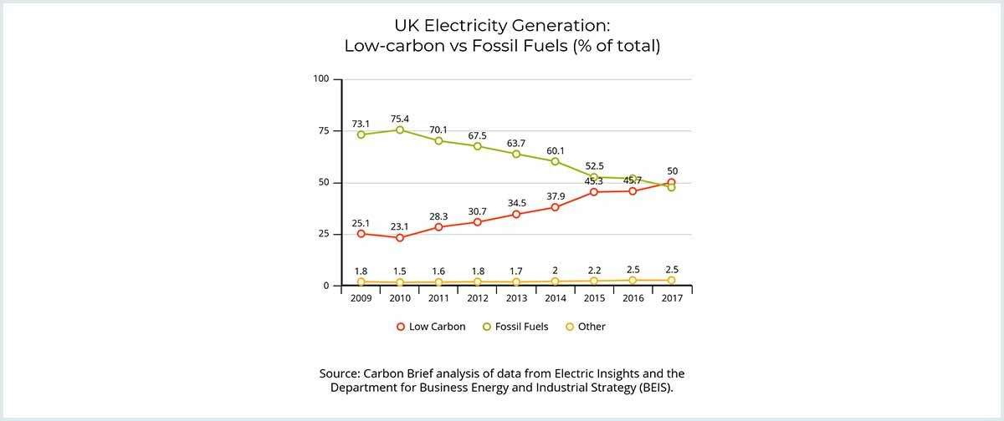

Note about the graph: “Low-carbon” includes nuclear, bioenergy, solar, wind and flow hydro. “Fossil fuels” includes coal, gas and oil. “Other” includes pumped hydro, which stores the grid mix of fuels, as well as non-renewable wastes.

Unfortunately, despite the success in the electricity sector, progress in other areas – including how we heat our buildings – has stalled according to the CCC:

“Meeting future carbon budgets and the UK’s 2050 target to reduce emissions by at least 80% of 1990 levels will require reducing domestic emissions by at least 3% per year. This will require existing progress to be supplemented by more challenging measures.”

The UK is not on track to meet the fourth carbon budget which covers the period 2023-27.

Legislation was put in place in 2018 to phase out inefficient gas boilers; the regulation now known as ‘Boiler Plus’ stipulates that all new Combi boilers installed must have a minimum energy efficiency of 92%. The UK government hopes to phase out the gas network almost completely by 2050, and in March 2019 it was confirmed that from 2025 it will be illegal to install gas boilers in new build homes.

The Future of Gas Heating

According to the National Grid, 8/10 homes in the UK are connected to the gas grid for heating, so what will the gas network be replaced by? In November 2018 the CCC released their most recent findings and recommendations for the future of UK heating with particular focus on finding an alternative to the natural gas network.

The report suggests that the most likely solution looks like a hydrogen network. When burned, hydrogen produces no emissions and creates only water vapour and heat. Hydrogen is also very efficient as it contains a large amount of energy; 1kg of hydrogen has the same amount of energy as 2.8kg of gasoline.

However, the report also highlights the need for careful planning as switching the gas grid to 100% hydrogen is impractical for zero carbon heat. The UK’s natural gas grid is extensive but it’s unlikely that reusing the existing grid entirely to burn hydrogen in domestic boilers as we do with natural gas today would be a viable option. The report suggests that the better tactic would be to combine different renewable technologies to provide low-carbon heat.

Specifically, the CCC recommends that the lowest cost, long term solution is to replace the millions of gas boilers across the UK with hydrogen alternatives alongside electric heating (generated from renewable sources).

Initially, householders would keep their radiators and gas boilers but the majority of their hot water would be produced by an air source or ground source heat pump (which run on a small amount of electricity to draw natural heat from either the air or ground) with the gas boiler there as a backup. To make heat pumps effective all existing and new build homes need to be made as energy efficient as possible with optimum levels of insulation.

To reach the 80% reduction target, the next stage would be to replace the gas boilers with hydrogen ones.

Chief executive of the CCC, Chris Stark, said:

“I’ve been cautious about the hydrogen story, because it’s often portrayed as a panacea. [But] I’ve been surprised how well it’s come out of our modelling when it’s accompanied by energy efficiency and electrification from heat pumps.”

What are the Challenges of a Hydrogen Network?

Switching from gas to [hydrogen boilers](https://www.boilerguide.co.uk/articles/hydrogen-boilers-alternative-gas-central-heating) would be a huge project and carries a number of challenges. For example, hydrogen is generally considered hazardous as it’s highly flammable so this will need to be addressed for use in domestic settings.

In addition, while hydrogen emits zero emissions when used, the process of creating it does produce carbon so a production system will need to be developed which captures the carbon so it doesn’t get released into the atmosphere. This can be done as currently around 90% of the world’s hydrogen is produced in steam methane reformers. This combines natural gas with steam, which separates the hydrogen and the carbon. The carbon is then stored so it is not leaked into the atmosphere.

Another potential challenge the government face is the limited public awareness around the need for decarbonised heating and what would be involved in making the switch. To get UK homeowners on board with the changes the government need to address concerns around the hassle of a new installation, the unfamiliarity of a new heating technology and the worry that the new systems won’t be as effective as traditional boilers.

The CCC’s main recommendations to combat these challenges are:

* Government must commit to developing a low-carbon heat strategy within the next three years.
* Significant volumes of low-carbon hydrogen should be produced in a carbon capture and storage (CCS) ‘cluster’ by 2030 to help the industry grow.
* Government must support the early demonstration of the everyday uses of hydrogen in order to establish the practicality of switching from natural gas to hydrogen.
* There needs to be public engagement on the future of the UK’s heating choices. However, the window to engage with people is closing.

Lord Deben, Chairman of the Committee on Climate Change (CCC), said:

“Hydrogen has the potential to contribute to near-zero carbon energy emissions if used strategically. The Government must now decide whether it wishes to develop a UK hydrogen option, taking decisions now that will see the first deployment in the 2020s. This must be in parallel with efforts to improve energy efficiency, build further low-cost renewables and get carbon capture and storage underway. The time for the Government to move from theory to practice has arrived […] The future now rests on Government making a quick decision and fully committing to low-carbon heat within the next three years.”



How Does a Hybrid Heating System Work?



A hybrid heating system is a combination of a traditional boiler with an [air source heat pump.](https://www.boilerguide.co.uk/air-source) This technology is a particularly good option for homeowners looking to keep the familiarity of the boiler we all know so well but with the energy saving benefits of a renewable technology.

Daikin’s Altherma Hybrid is one of the most sophisticated examples of this technology. The smart system will automatically switch between the gas or LPG boiler and the air source heat pump, depending on which is the most economical or ecological operation. It can also be monitored and controlled from a simple app on your smart device for maximum convenience. It will work in even the coldest UK temperatures to provide both heating and hot water and if either the boiler or heat pump were to break down, the other would kick in so you won’t go without hot water or heating.

If you’re replacing a gas or LPG boiler then an Altherma hybrid is a relatively straightforward installation. The system includes a Combi boiler which can simply replace your existing boiler, connecting to your radiators or underfloor heating, as well as an air source heat pump which is installed outside the home. It can also be installed alongside a separate hot water cylinder or solar thermal system to increase the hot water supply for larger homes.

The heat pump element of a hybrid system is eligible for the RHI scheme so could your system could be earning you money at the same time as reducing your energy bills.

Head of Heating and Renewables at Daikin said in an interview with a heating industry publication recently:

“The heating market in the UK is changing with a move towards electrification and decarbonisation. The Altherma 3 is the latest innovation in the domestic heat pump sector and will take you and your business forward into this changing heating market. There may be a place for hydrogen in the gas main however my personal opinion as head of heating and renewables is that it is not the correct solution for reducing our carbon emissions. We have to move away from our reliance on fossil fuels.”

What About Heating in Off-grid Homes?

For the homes in the UK not connected to the gas network which run on oil, LPG or coal heating systems, changes may be even closer to home. The government has talked of replacing oil, coal and LPG heating systems with renewable energy alternatives by as soon as 2025. There are no concrete strategies in place, but the government’s Clean Growth Plan states: “Our ambition is to phase out the installation of high carbon fossil fuel heating in new and existing off-gas grid residential buildings (which are mostly in rural areas) during the 2020s.”

However, the UK’s trade association for oil fired appliances, OFTEC (Oil Firing Technical Association), argues that replacing oil boilers is not the solution for off-grid homes.

In 2017 OFTEC unveiled its strategy for the future of off-grid heating, based on a 2-stage approach:

* Stage 1 from 2018 – 2022: incentivise the replacement of existing standard efficiency oil boilers with high efficiency condensing appliances through a nationwide boiler replacement programme. This should be supported by mandating heating controls such as functional timers and thermostats when new boilers are installed to further reduce energy use.
* Stage 2 from 2022: introduce a low carbon liquid fuel as a replacement to kerosene.

OFTEC believes that this strategy will address carbon reduction and energy efficiency simultaneously and means that homeowners won’t have the high upfront cost of replacing an entire heating system. In addition, replacing the fuel rather than the boiler will mean there will already be a network of engineers and suppliers in place to support the transition.

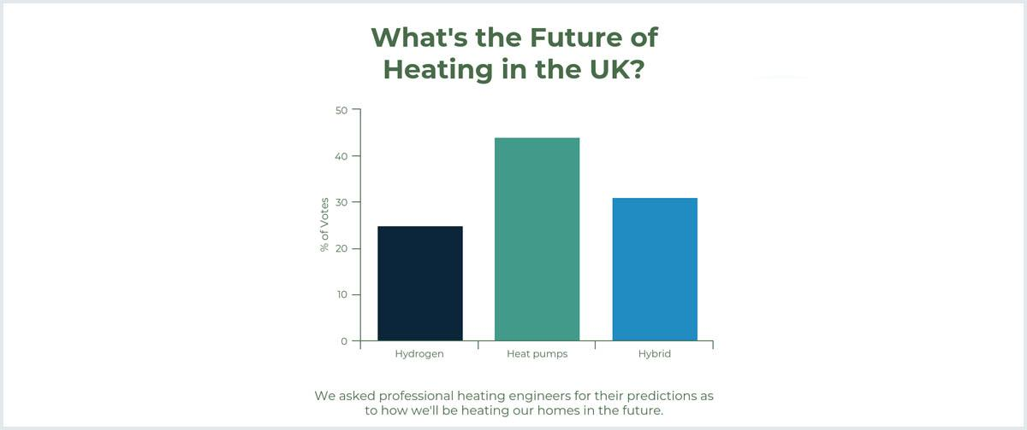

Other Renewable Heating Systems

Solar Thermal



In many ways solar thermal is similar to solar PV, but rather than turning the sun’s energy into electricity this system uses it to heat your water. This solar heated water can supply a wet central heating system as well as your taps, baths and showers.

By using the sun’s free energy to heat your water you will need to use your boiler less. This means cheaper heating bills, lower carbon emissions and less strain on your boiler.

* Solar thermal panels (also known as collectors) are fitted to your roof. The panels include tubes of fluid which absorb heat from the sun’s energy.
* This hot fluid travels down into your home and the heat is transferred to your hot water storage tank via a heat exchanger.
* This hot water then travels around your pipes as it would in a standard wet heating system.

A solar thermal system is also eligible for the government’s Renewable Heat Incentive (RHI) scheme which will pay you for the energy generated by the system on a quarterly basis for 7 years. Find out more about Solar Thermal heating here.

Note: If you have an electric heating system or an immersion heater then solar PV panels will generate electricity for these systems.

Biomass boilers



A biomass boiler is like the standard gas and oil boilers you find in most homes, but it is fuelled by solid biomass rather than gas or oil. Biomass is biological material that comes from plants or plant-based organisms. When it comes to domestic boilers this material is usually wood logs, chips or pellets. It is eligible for the government’s RHI scheme.

Burning wood, on the other hand, is a carbon neutral process which means it only produces as much carbon dioxide as the tree absorbed while it was growing, cancelling itself out. As a naturally occurring fuel like coal it is much more sustainable. Unlike coal, wood does not take millions of years to form. In addition, UK landfill sites take in millions of tonnes of waste wood every year. This means that using wood as fuel is not only healthier for the planet’s atmosphere but will also take the strain off our landfill.

What Should Homeowners Do Now?

If your current oil, LPG or coal heating system is on its last legs or operating inefficiently, now may be the time to consider a renewable alternative or, at the very least a new, more efficient oil boiler.

Homes on the gas network have a little more breathing space, but should only be installing only the most efficient boilers to minimise their carbon emissions and (where possible) combining their gas boiler with a renewable system like solar thermal or a heat pump.

New builds are our biggest opportunity to ensure renewable systems and effective insulation are integrated into our homes going forward, but as current homeowners we should consider (and be as open-minded as possible) about renewable energy as part of any renovations or extensions.

The main thing to remember – and it’s what is making the issue so complicated – is that there will be no one size fits all solution to the future of UK heating. The technology which works best in a 5 bedroom remote, farmhouse can’t be applied to an inner city 2 bed terrace. Households with lower incomes cannot be expected to meet the upfront costs of renovations without financial support and every family lifestyle and routine is unique. As the government and the energy industry continue to research, test and debate the long term future, if you’re looking to make a change to your home heating now, we recommend that you talk to multiple professional heating engineers and work with them to find the right technology for your home and lifestyle.

Reputable and professional heating engineers have a responsibility to recommend heating solutions which are in your best interests and should be advocating the most energy efficient option where possible.

from：<https://www.boilerguide.co.uk/articles/the-future-of-heating-in-2050>